2014
PRATUSH SRIVASTAVA

[CURRICULUM VITAE]

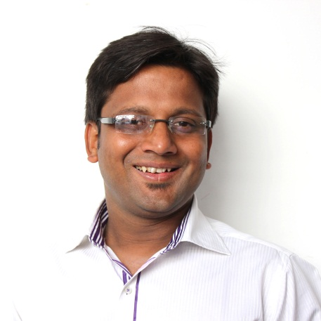
PRATUSH SRIVASTAVA
archi.pratush@gmail.com
+9643405714(M)
S/O Mr. J.P. Srivastava, 8/369 Jankipuram Ext. Sitapur Rd., Lko.

OBJECTIVE
To strive to create a difference in your esteemed firm. I am attached to innovative, efficient and effective methods of work, based on my competencies, capabilities, skills, education and experience.

ACADEMIC PROFILE
MAY 2014 Completed Master’s Of Architecture(Urban Design)
Scored-10.53/15(3rd Rank)
THESIS TOPIC: New Mass Transit(Metro) As An Urban Artefact For
Transforming The City’s Form (A Case Of Lucknow )
(Judged 2nd best)
JUNE 2009 Integral University(formerly institute of integral technology),Lucknow
Bachelor Of Architecture (70% avg. score in 5 yrs)
Thesis Topic: National Press Centre(proposed media park for print and
electronic media) – scored 72%

JUNE 2002 Lucknow Public Inter College, Lucknow, U.P.(Affiliated to U.P. Board)
Score-70%

JUNE 2000 Lucknow Public Inter College, Lucknow, U.P.(Affiliated to U.P. Board)
Score-61%

EXPERIENCE
NOV 2009-NOV 2010 ARCOP ASSO. PVT. LTD. NOIDA
Ar. Nitin Gupta, Ar. Anand Prakash, Ar. Anubhav Arora
As an architect worked on Pavillion Heights 4,a residential towers of jaypee greens(involved in construction drawings, elevation development and co-ordination),Al-Hail Club in Muscat(involved in design and development and presentation drawings)

NOV 2010-JULY 2012 DESIGN&DEVELOPMENT INDIA PVT. LTD.
NEWDELHI
Ar. Vidur Bharadwaj, Ar. Hukum Thapa
As an architect worked on Lotus Panache Club(responsible for concept,design and development,presentation dwgs,construction dwgs and co-ordination), Oxyzen –SEZ(responsible for construction drawings and co-ordination),ACB Housing(responsible for concept design and presentation)

JUNE 2013-AUG 2013(TR.) VISHWAS KULKARNI AND ASSOCIATES, PUNE
Ar. Vishwas Kulkarni and Ar. Dwaipayan Chakrawarthy.
(worked as a trainee and involved in preparing Architect’s Compendium For Pune City and documentation and redesign of Fergussion College Road, Pune.

JUNE 2014-PRESENT ATS INFRASTRUCTURE PRIVATE LIMITED, NOIDA.
Ar. Manish Kr. Gupta (AVP)
(working as an senior architect on a residential development named as “ATS DOLCE”; involved in design and development, co-ordination of the project.)
Current CTC: 6.0 Lakhs

SKILLS
Software Skills Autocad(all versions), Revit 09&10, Adobe Photoshop, Sketch Up, MS
Office, Adobe Reader.
Language Skillls Hindi & English.

Interests Reading, Sketching, Photography, Travelling, Listening to music Learning
and exploring new softwares.

MAJOR STRENGTHS
Integrity and ethics, Team-oriented, Pro-active, Creative, Good communication skills and having leadership qualities.

AWARDS AND ACTIVITIES
- Attended north zone conference of institute of town planners, india in the year 2009.
- Attended a conference on green buildings in india in the year 2010. By teri & griha at ihc complex new delhi.
- Attended seminar on lucknow heritage buildings.
- Attended seminar on byelaws.

- Participated in design competition transparance-07 by saint gobain glass.

- Participated in nari gandhi trophy at nasa in the years 2005.

- Participated in A.N.D.C. Trophy at nasa in the years 2006,2007.

- Attended annual nasa held in mumbai in the year 2006
.
- Lingaraja temple, bhubaneshwar- a classic example of indo- aryan temple style, published in archi- design perspective- mar- april, 2006 issue.

- Chandigarh- the first designed city of independent india: the report was the outcome of the educational tour done in the year 2006-07. The town planning of chandigarh was studied and the ideologies of le corbusier were studied.

- Measure drawings of ‘lingaraja temple, bhubaneshwar’ in the year 2004-05.

.

